|  |  |  |
| --- | --- | --- |
|  | **BOSTON**  **UNIVERSITY** | **METROPOLITAN COLLEGE**  **DEPARTMENT OF ADMINISTRATIVE SCIENCES** |

**AD 616: Enterprise Risk Analytics- Aravind hanumantharao**

**Assignment 3**

**15-3-2023**

**What to submit?**

Please submit (i) a word file explaining in detail your answers to each question (you can use screenshots of the R to explain your answers) AND (ii) an R file with a separate tab for each question. For each question, make sure you develop the model and present the simulation results – the R file should be self-explanatory. **The assessment of your work will include both the accuracy and the clarity of your word file and the R file. But even if you are struggling with R, we will grade favorably if you demonstrate your understanding of the concepts and how you are planning to solve the problem.**

1. GWS is a company that markets outboard motorboats directly to consumers for recreational use. Recently, they’ve been developing a project they think has a lot of potential: the first mass market boats with electric motors. They haven’t started advertising their new product yet, nor have they organized a presale because they don’t want to lose their first-mover advantage. As a result, GWS has a limited understanding of the size of the market for their new project. They plan to retail their boats for $150,000, but after two years, when competition enters the market and the novelty factor wears off, they’ll have to drop the price to $70,000. They hire a consultant who estimates that at this price point, over the next two years, demand for the new boats will be somewhere between 2,000 and 15,000, with probabilities as in the table below:

|  |  |
| --- | --- |
| Demand | Probability |
| 2,000-5,000 | 35% |
| 5,001-10,000 | 40% |
| 10,001-14,000 | 20% |
| 14,001-15,000 | 5% |

The fixed cost of manufacturing any number of boats is normally distributed, with a mean of $300 million and a standard deviation of $60 million. They estimate that the variable cost to produce one boat will be a minimum of $77 thousand and a maximum of $100 thousand, with a most likely value of $90,000. Develop four Monte Carlo Simulations to calculate their total profit over the two year period assuming they produce

1. 4,000 boats
2. 8,000 boats
3. 12,000 boats
4. 15,000 boats

For each simulation, provide the mean and standard deviation as well as a histogram.

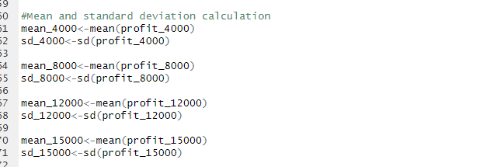

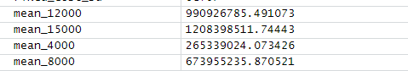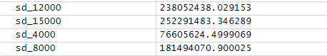

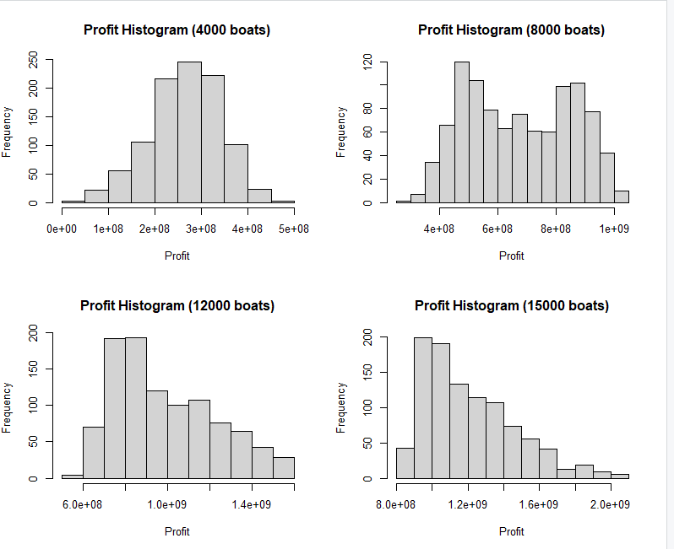

1. The Baker’s Inn is a small chain of restaurants in the New England area, that, in addition to accepting reservations, allow patrons to reserve an event space for private functions. Until now, the chain has limited reservations for its event spaces to parties of ten or more. The proprietor of the chain is considering expanding the spaces or possibly ceasing to offer private functions, but wishes to model the revenue they can generate. The chain collects data on the previous 100 private functions, including the number of people in each party and the amount each party spent per person (see .csv file).
2. Create a histogram of the party sizes. Which distribution do you think would best fit the data? Choose from among discrete uniform, geometric, and Poisson.

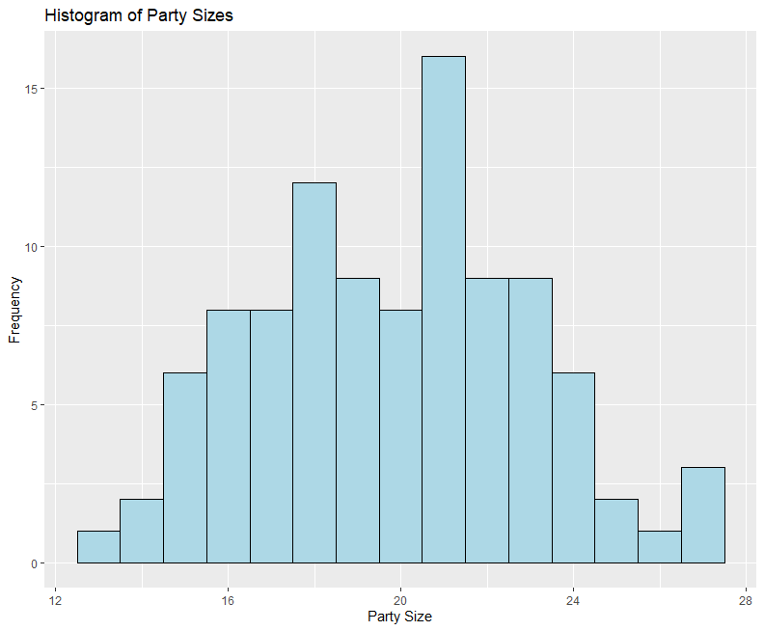 Based on the histogram of the party sizes, I think that Poisson distribution would be the most appropriate fit for this dataset.

1. In order to best fit the data, we need to shift the distribution to the left by subtracting a positive integer from the value of party size. What number should we subtract to get the best fit? What are the parameter(s) of the best fit distribution?

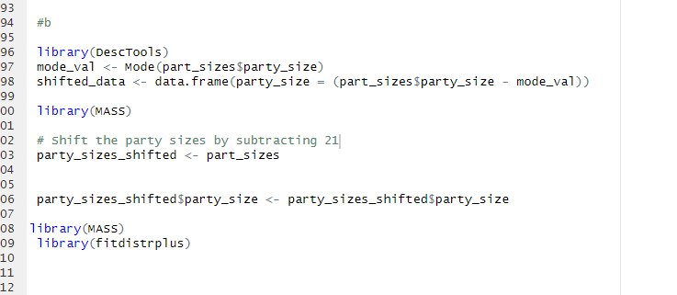



21 is appearing the most and this value needs to be subtracted to the left , to best fit the data

What are the parameters –

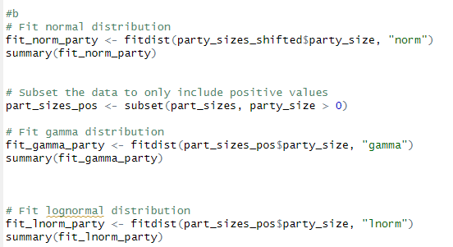

Looking at the summary –

**Gamma** -had the lowest AIC

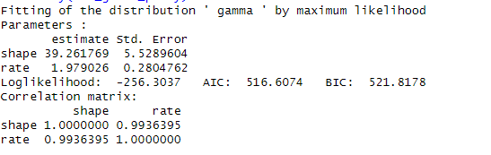

LNORM-

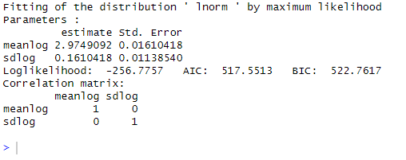

NORM-

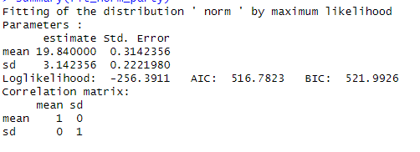

We need to choose gamma as our parameter because it has the lowest AIC.

1. We now need to fit a distribution to the per person spending. Which of the following distributions results in the best fit, according to the KS statistic: Cauchy, gamma, logistic, lognormal, normal, or Weibull? What are the parameter(s)?

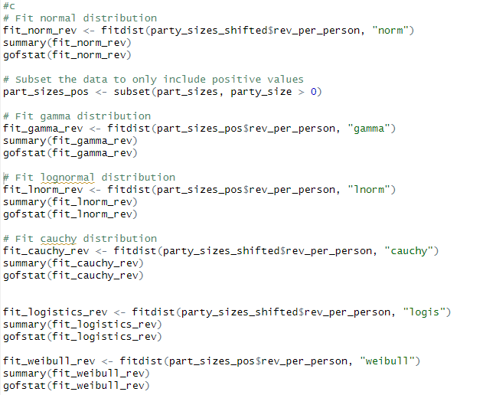

Conducting all the k- test , I came to a conclusion –

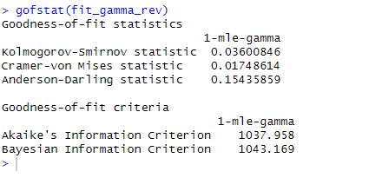

The k test proves that , gamma had the lowest value and I need to choose that parameter.

1. Create a QQ plot and a density comparison plot for the distribution you chose from part (c). Does the distribution appear to be a good fit?

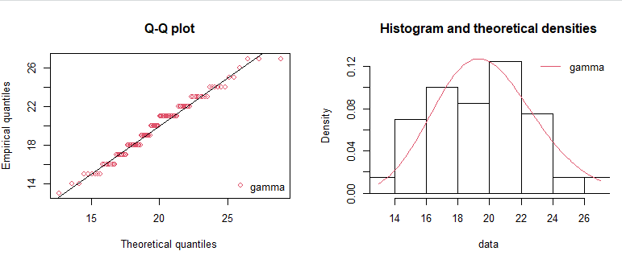

Yes the plot is a good fit and seen the points are closer to the line and the distribution is normally distributed towards the centre.

1. Does it appear that party size and per person spending are correlated?



Yes it is moderately positively correlated .

1. Using the distributions and parameters from parts (a)-(c) and the correlation from part e, construct an MC simulation with 100,000 trials to create a risk profile for the revenue generated from a single event. Create a histogram and provide the mean and standard deviation. (Hint: don’t forget to shift the distribution of party size back to the right.)

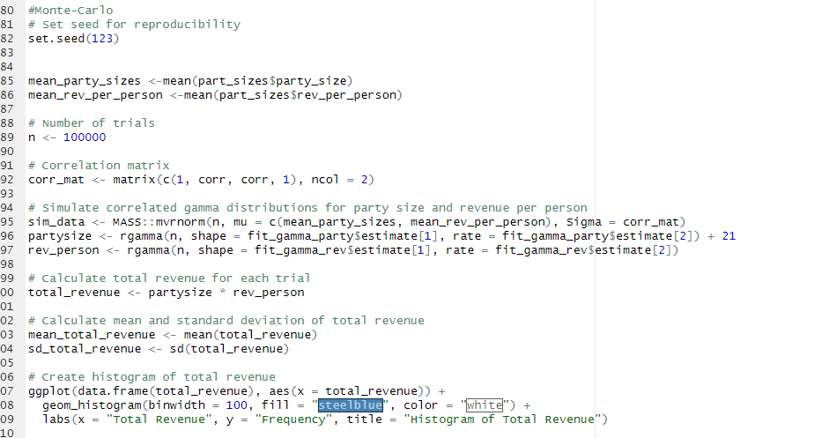





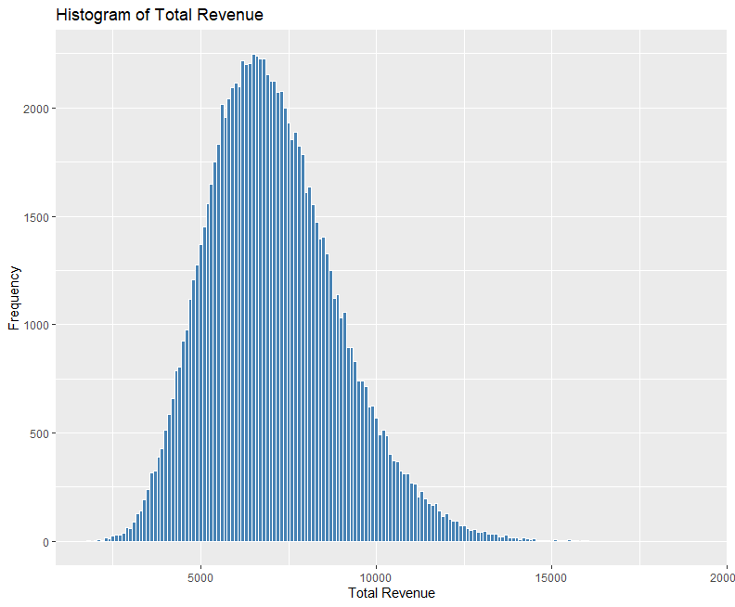

1. According to your simulation, how often will a private function generate at least $5000?

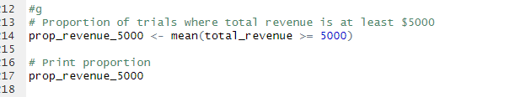



87 percent of the times the values are above 5000.

1. Repeat parts (f) and (g), but build a simulation that ignores the correlation. How does this affect your results?

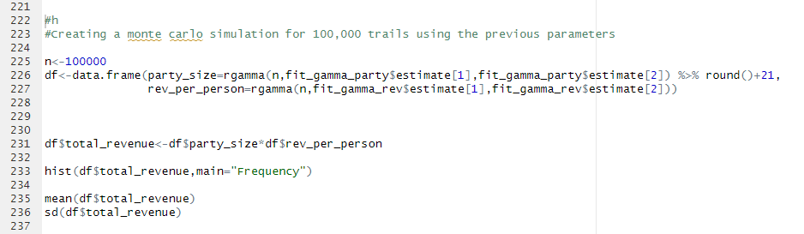

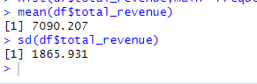

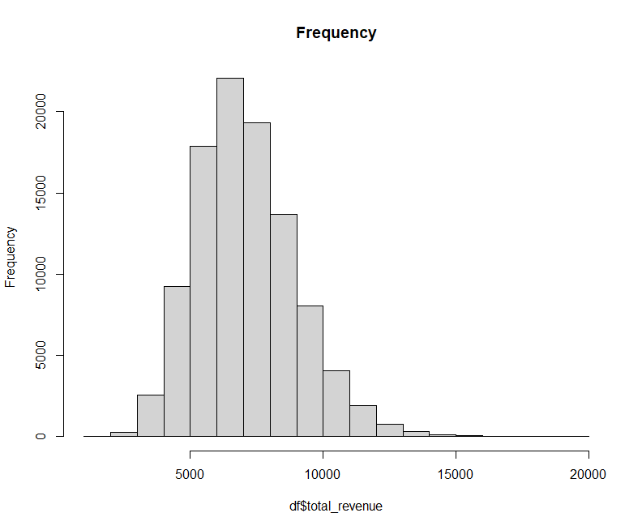

Not having the correlation , the mean and the standard deviation increases from before . That’s the only change from the correlation equation.